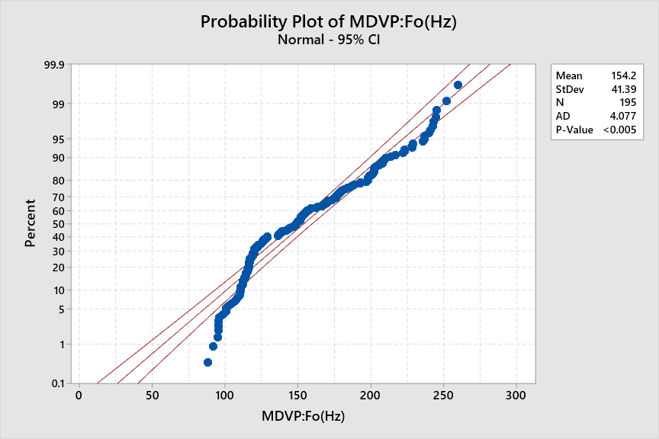

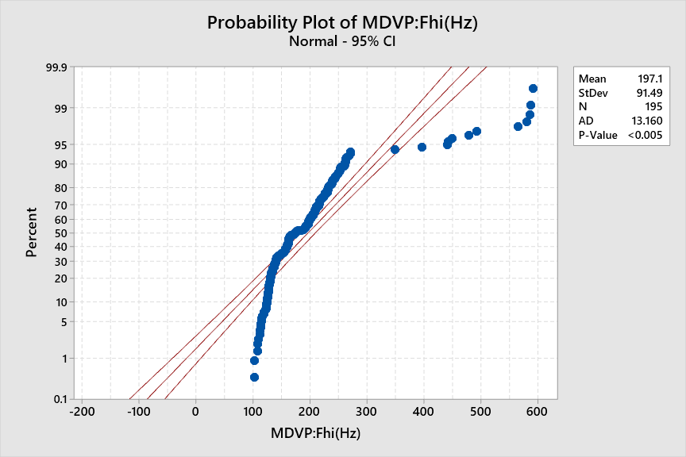

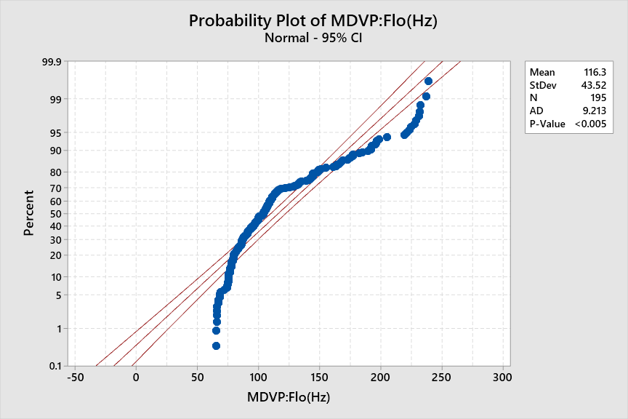

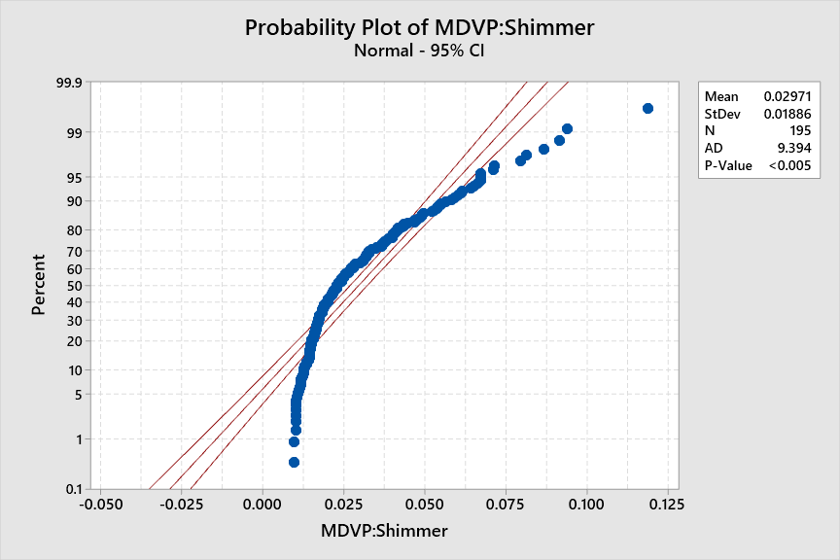

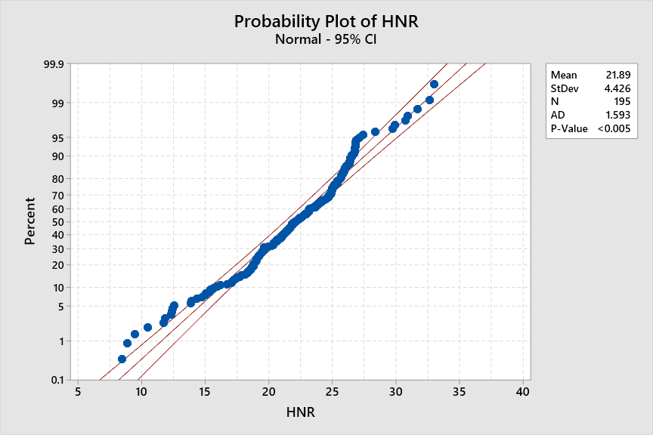

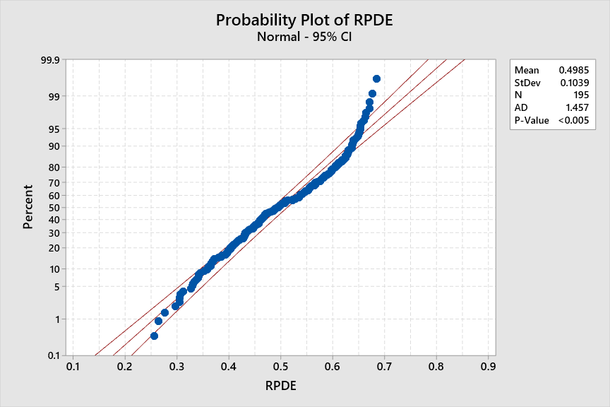

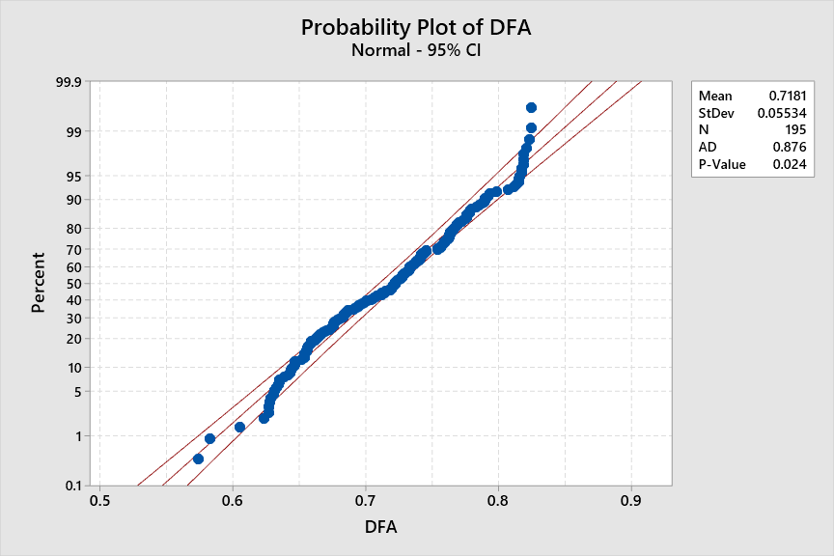

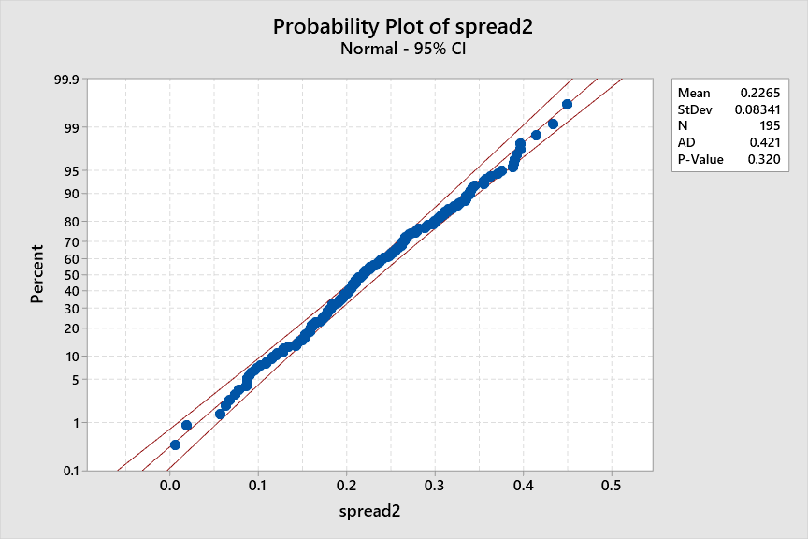

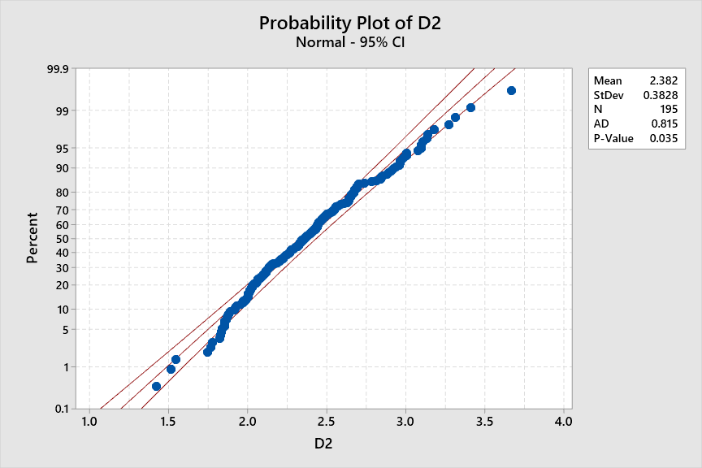

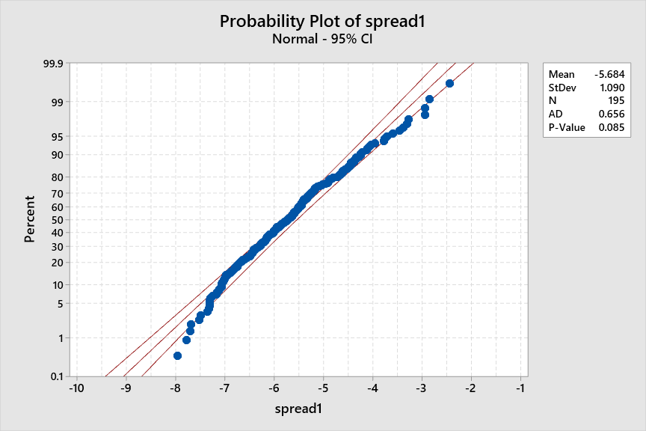

**Descriptive Statistics**

|  |  |  |  |
| --- | --- | --- | --- |
| **N** | **Event** | **Sample p** | **95% CI for p** |
| 195 | 147 | 0.753846 | (0.693385, 0.814307) |

**Test**

|  |  |  |  |
| --- | --- | --- | --- |
| Null hypothesis | | | H₀: p = 0.7 |
| Alternative hypothesis | | | H₁: p ≠ 0.7 |
| **Z-Value** | **P-Value** |
| 1.64 | 0.101 |

Or

**Descriptive Statistics**

|  |  |  |  |
| --- | --- | --- | --- |
| **N** | **Event** | **Sample p** | **95% CI for p** |
| 195 | 147 | 0.753846 | (0.693385, 0.814307) |

**Test**

|  |  |  |  |
| --- | --- | --- | --- |
| Null hypothesis | | | H₀: p = 0.6 |
| Alternative hypothesis | | | H₁: p ≠ 0.6 |
| **Z-Value** | **P-Value** |
| 4.39 | 0.000 |